1.6 List four applications you have used that most likely employed a database system to store persistent data

1. kaspi, homebank, etc in other words banking apps. They used dbs for account information, transfer of funds, banking transactions;
2. wsp, kundelik, etc education based apps. They used dbs for student information, online assignment submissions, course registrations, and grades;
3. Online booking apps from airlines, railways, reserving hotel like booking. They used dbs for reservation of tickets, and schedule information;
4. Any online shops or trading apps like koleso, krysha, wildberries, aliex[ress, etc. They used dbs for product data, availability and pricing information, order-tracking facilities, and generating recommendation lists

1.7 List four significant differences between a file-processing system and aDBMS.

1. In a File System, data is directly stored in set of files.  It contains flat files that have no relation to other files, so it allows to access only one file at a time, while Database Management System (DBMS) is a application software that allows users to efficiently define, create, maintain and share databases;
2. Data redundancy and inconsistency: Redundancy is the concept of repetition of data i.e. each data may have more than a single copy. The file system cannot control the redundancy of data as each user defines and maintains the needed files for a specific application to run. There may be a possibility that two users are maintaining the data of the same file for different applications. Hence changes made by one user do not reflect in files used by second users, which leads to inconsistency of data. Whereas DBMS controls redundancy by maintaining a single repository of data that is defined once and is accessed by many users. As there is no or less redundancy, data remains consistent.
3. Data sharing: The file system does not allow sharing of data or sharing is too complex. Whereas in DBMS, data can be shared easily due to a centralized system.
4. Data concurrency: Concurrent access to data means more than one user is accessing the same data at the same time. Anomalies occur when changes made by one user get lost because of changes made by another user. The file system does not provide any procedure to stop anomalies. Whereas DBMS provides a locking system to stop anomalies to occur.

1.8 Explain the concept of physical data independence and its importance indatabase systems.

Physical Data Independence is defined as the ability to make changes in the structure of the lowest level of the Database Management System (DBMS) without affecting the higher-level schemas. Hence, modification in the Physical level should not result in any changes in the Logical or View levels.

**Note –**   
There are 3 levels in the schema architecture of DBMS: Physical level, Logical level, and View level (arranged from the lowest to highest level).

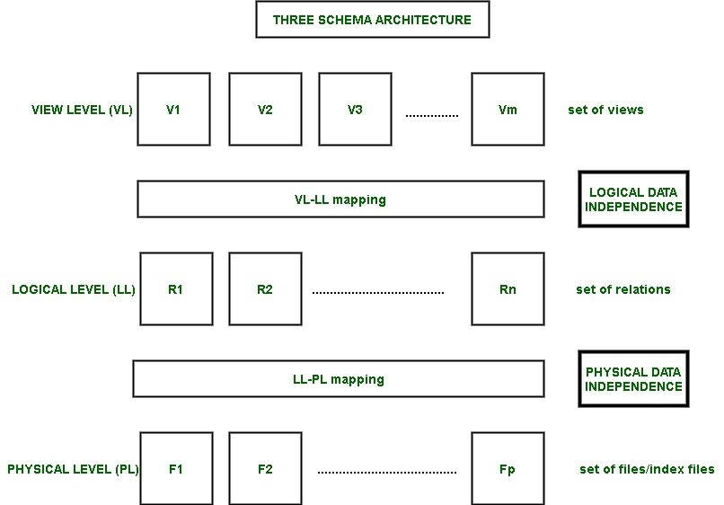

Example –   
Changes in the lowest level (physical level) are: creating a new file, storing the new files in the system, creating a new index, etc.

Instances of why we may want to do any sort of Data modification at the physical level- We may want to alter or change the data at the physical level. This is because we may want to add or remove files and indexes to enhance the performance of the database system and make it faster. Hence, in this way, Physical Data Independence enables us to do Performance Tuning. Ideally, when we change the physical level, we would not want to alter the logical and view level.

How is Physical Data Independence achieved?

Physical Data Independence is achieved by modifying the physical layer to logical layer mapping (PL-LL mapping). We must ensure that the modification we have done is localized.

1.9 List five responsibilities of a database-management system. For each responsi-bility, explain the problems that would arise if the responsibility were not dis-charged.

1. interaction with the file manager
2. integrity enforcement
3. security enforcement
4. backup and recovery
5. concurrency control

If these responsibilities were not met by a given DBM the following problems can occur, respectively

1. No DBMS can do without this, if there is no file manager interaction then nothing stored in the files can be retrieved.
2. Consistency constraints may not be satisfied, account balances could go below the minimum allowed, employees could earn too much overtime (e.g., hours > 80 hours) or, airline pilots may fly more hours than allowed by the law.
3. Unauthorized users may access the database, or users authorized to access part of the database may be able to access parts of the database for which they lack authority. For example, a high school student could get access to national defense secret codes, or employees could find out what their supervisors earn.
4. Data could be lost permanently, rather than at least being available in a consistent state that existed prior to a failure.
5. Consistency constraints may be violated despite proper integrity enforcement in each transaction. For example, incorrect bank balances might be reflected due to simultaneous withdrawals and deposits, an so on.

1.11 Assume that two students are trying to register for a course in which there is onlyone open seat. What component of a database system prevents both studentsfrom being given that last seat?

The component of the database that prevents both students from getting the last seat is: transaction isolation

Data that enters the database are expected to maintain accuracy and also be consistent with the database structure.

So, when both students request for the last seat, the possibilities are:

* *Student A gets the seat*
* *Student B gets the seat*

The following is not a possibility

* *Both students get the seat*
* *None of the students gets the seat*

The above highlights means that, only one of the students would get the seat.

This is possible because of the concept called transaction isolation.

The transaction isolation ensures that the data requested by a user is *complete*and such data maintains *competency*.

So, when a student gets the last seat, the *next student*would not get the same seat (*or any other seat*), because a transaction has already been completed.

1.15   
Describe at least three tables that might be used to store information in a social-networking system such as Facebook

a) A users table containing users, with attributes such as account name, real name, age, gender, location, and other profile information

b. A content table containing user provided content, such as text and

images, associated with the user who uploaded the content.

c. A friends table recording for each user which other users are connected to that user. The kind of connection may also be recorded

in this table.

d. A permissionstable, recording which category of friends are allowed

to view which content uploaded by a user. For example, a user may

share some photos with family but not with all friends.